Relax, Eat, Drink…BUT
DON’T LET YOUR GUARD DOWN!

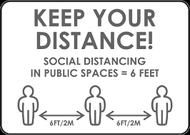

Donn and Doff Your Mask Properly
Practice Proper Hand Hygiene
Clean Up After Yourself

IMPORTANT!

WEAR YOUR MGH-ISSUED MASK PROPERLY
AND AT ALL TIMES
UNLESS EATING OR
ALONE IN A PRIVATE OFFICE

VIOLATORS WILL LOSE
ACCESS PRIVILEGES
TO ALL MGH BUILDINGS

