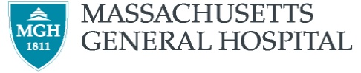

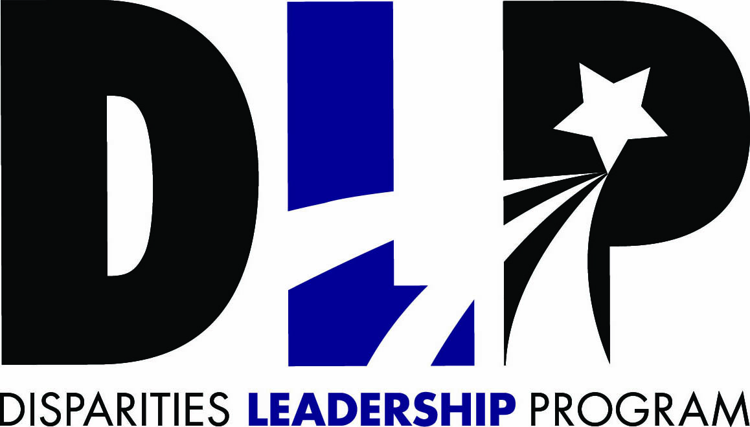

Empowering Leaders. Getting to Solutions.

Developed and led by
The Disparities Solutions Center at Massachusetts General Hospital

Winner of the
2014 American Hospital Association Equity of Care Award
and the AAMC Learning Health System Award

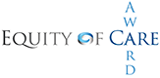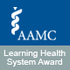

Jointly sponsored by
The National Committee for Quality Assurance
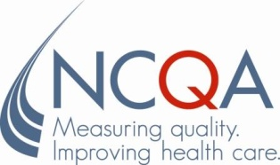

Supported by
Joint Commission Resources, Inc. (An Affiliate of The Joint Commission)

What we have learned from working with other health care organizations for over a decade is that there is a thirst for knowledge on how to operationalize and execute on strategies to address racial and ethnic disparities, but also to be part of a community that can crowd source ideas.

Aswita Tan-McGrory, MBA, MSPH
Director, The Disparities Solutions Center at Massachusetts General Hospital
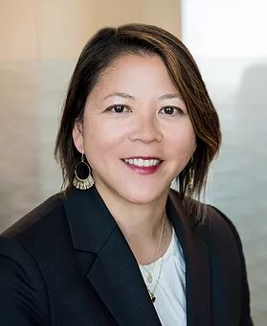

Pursuing High-Value Health Care: Improving Quality and Achieving Equity

The implementation of health reform and current efforts in payment reform herald a significant transformation of the United States health care system. Across the country, health care organizations are expanding access to health care that aims to be high-quality and cost-effective. Pursuing high-value health care is the ultimate goal. At the same time, our nation is becoming increasingly diverse. Following enactment of the Patient Protection and Affordable Care Act, Black, Hispanic, Asian, American Indian and Pacific Islander populations experienced large gains in coverage from 2010-2016, with the Hispanic population experiencing the largest gains. While disparities in coverage still exist, the insured population is decidedly more diverse.

Guided by The Institute of Medicine (IOM) Report Crossing the Quality Chasm, our nation charts a path towards quality health care that aims to be safe, efficient, effective, timely, patient-centered, and equitable. Achieving equity requires that the quality of care we deliver—and that patients receive—does not vary based on patient characteristics such as race/ethnicity, gender, sexual orientation, and disability status. However, research demonstrates that our nation falls well short of this goal, as we know significant disparities exist. For example:

- Black patients, Medicaid, and under-insured patients make up a disproportionate share of emergency department visits for chronic ambulatory care-sensitive conditions.
- Patients with limited English proficiency (LEP) are more likely to suffer adverse events with more serious consequences than their white, English-speaking counterparts.
- Chinese and Spanish speakers, as well as Black and other people of color, have higher readmission rates for heart attack, heart failure, and pneumonia than their English-speaking, white counterparts.
- People of color are less likely to receive wellness care such as cancer screenings.

In this era of health care transformation, it has become clear that these disparities are in fact the epitome of low–value: care that is of poor quality and costlier. In fact, researchers have determined that between 2003 and 2006, the combined direct and indirect cost of health disparities in the US was $1.24 trillion. Thirty percent of direct medical expenditures for African American, Asian, and Hispanic patients were excess costs due to health inequities. If we are to be successful in our pursuit of value, we must be prepared to deliver high-quality and high-value health care to an increasingly diverse population. Disparities are a high-value target and addressing them will allow health care organizations to gain a competitive edge in a changing market.

Preparing for Healthcare Transformation: The Disparities Leadership Program

The Disparities Solutions Center (DSC) at Massachusetts General Hospital is dedicated to helping health care leaders address disparities and achieve equity in a time of healthcare transformation. The Disparities Leadership Program will equip you with the knowledge, tools, and strategies you will need to address disparities and deliver high-value, quality care to all.

Since 2005, the DSC has worked to improve health care quality for every patient, regardless of race, ethnicity, culture, class, or language proficiency. Our work is focused on developing actionable strategies to improve quality and achieve equity that are designed for those on the frontlines of health care. We provide tools to identify disparities, develop models to address them, and then work closely with health care leaders to deploy them in their unique care settings. From our home at the Massachusetts General Hospital and Harvard Medical School, we draw on our rich legacy of conducting cutting-edge research and translating it into practical, actionable strategies that are built to be integrated in real care settings. Our multidisciplinary group – with expertise in health policy, disparities, quality improvement, clinical care, patient experience, and organizational transformation – is committed to working closely with health care stakeholders to help achieve equity in this time of healthcare transformation.
Specifically, we:
- Create change by developing new research and translating the findings into policy and practice.
- Find solutions that help health care leaders, organizations, and key stakeholders ensure that every patient receives high-value, high-quality health care.
- Encourage leadership by expanding the community of health care professionals prepared to improve quality, address disparities, and achieve equity.
The Disparities Leadership Program (DLP) is our year-long, hands-on executive education program focused exclusively on helping health care leaders achieve equity in quality. The program is designed to help you translate the latest understanding of disparities into realistic solutions you can adopt within your organization.
Through the DLP, we develop leaders prepared to meet the challenges of health care transformation by improving quality for populations who experience disparities. The program has three main goals:
- To equip health care leaders with a rich understanding of the causes of disparities, the vision to implement solutions, and the strategies to transform their organization to deliver high-value health care.
- To help leaders create strategic plans or projects to advance their work in reducing disparities in a customized way, with practical benefits tailored to every organization.

- To create a professional learning and networking environment for leaders in health care to engage in peer-to-peer learning, crowd sourcing of ideas and strategies for reducing disparities, resource sharing, collaboration, and ongoing support in the form of a national DLP alumni network.

The DSC has the unique advantage of 14 years of experience developing and implementing the DLP, the only program of its kind in the nation.
To date, the DLP has trained 13 cohorts that include a total of 479 participants from 207 organizations (105 hospitals, 53 health plans, 21 community health organizations, and 28 others, including professional organizations, hospital trade organizations, schools of medicine, and federal and state government agencies) representing 33 states, Washington D.C., the Commonwealth of Puerto Rico, Canada, and Switzerland.

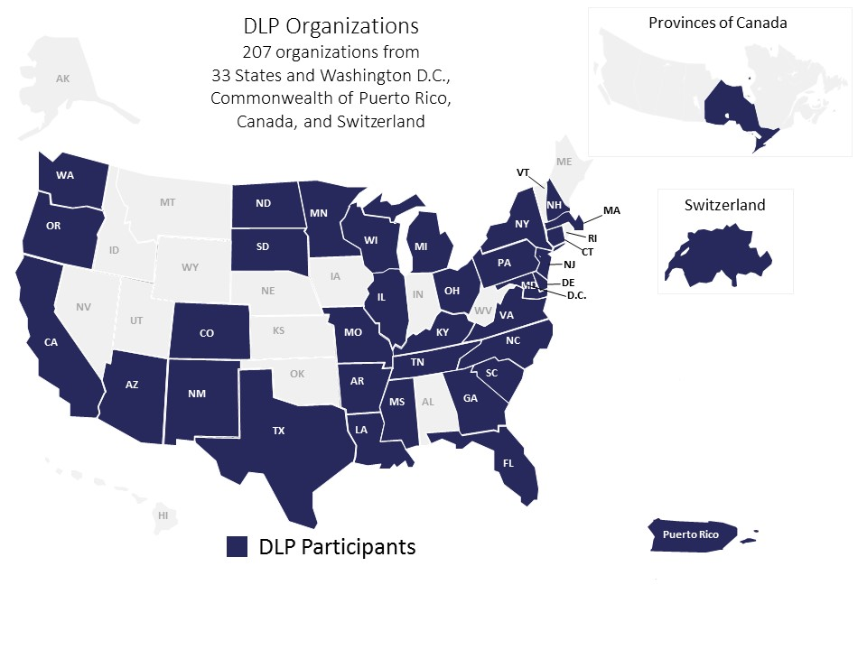

Leaders of health care organizations need to be prepared to improve quality and achieve equity in today’s health care environment characterized by a focus on achieving value and addressing disparities in a diverse population. To help address this need, the Disparities Solutions Center at Massachusetts General Hospital launched the Disparities Leadership Program in 2007. Feedback from participating organizations demonstrates that health care leaders seem to possess knowledge about what disparities are and about what should be done to eliminate them. Data collection, performance measurement, and multifaceted interventions remain the tools of the trade. However, the barriers to success are lack of leadership buy-in, organizational prioritization, energy, and execution, which can be addressed through organizational change management strategies.

A peer reviewed article in Health Affairs on the lessons learned from the DLP, as well as an external evaluation of the program, are available at: https://www.mghdisparitiessolutions.org/dlp-evaluation

“What DLP has done is to awaken a part of me. It brought me to an awareness level that has made me more well-rounded… This program has made me think about patients and families differently, it has helped me think about the community differently, making my work with the community much stronger... It has made me more sensitive and appreciative of differences. It has made me much stronger as a leader.”
- DLP Alum

x
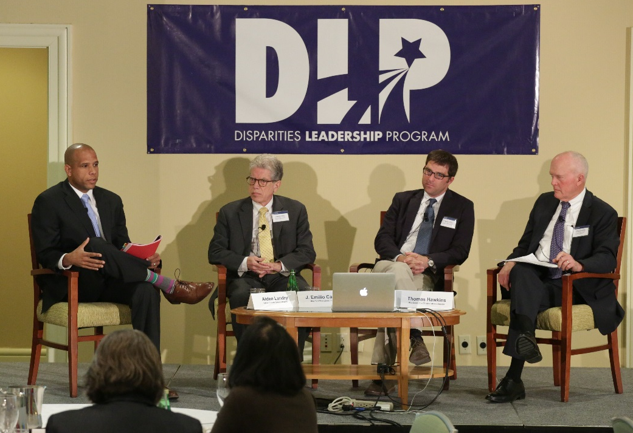

Who should apply?
The DLP is for leaders who recognize that disparities are variations in quality that impact outcomes and the health care bottom line; it is for pioneers who seek solutions to improve quality, achieve equity, and deliver value within the context of health care reform and transformation while focusing on meeting the needs of diverse populations.

Participants in our program come from a variety of disciplines and backgrounds and a range of organizations, including hospitals, health plans, physician groups, community health centers, and other care settings. Their roles include, among others:
- Executive Leadership
- Medical Directors
- Chief Diversity Officers
- Vice Presidents of Quality
- Directors of Patient Care Services
- Directors of Multicultural Affairs or Community Benefits

Teams of at least two participants from a given organization are routine, yet we encourage larger teams if beneficial and can work with individuals as well. To maximize the benefits of the DLP, your organization should have a strong commitment to solving the problem, as well as resources available to create change. Our team can work with you to find and strengthen those resources within your organization.

For a list of current and past DLP participants, visit https://www.mghdisparitiessolutions.org/alumni-network.

What will I gain from the DLP?
Addressing disparities and improving the value of health care requires leadership, vision, teamwork, and an understanding of the problem and potential solutions. The DLP is designed to build your knowledge and skills in these key areas while connecting you with other leaders and organizations working toward the same goal.

As a DLP participant, you’ll gain tools you can apply immediately at your organization to improve health equity:
- A Strong Network and Community of Peer Leaders. Through the DLP, you’ll collaborate with other like-minded individuals dedicated to solving this problem. You’ll be able to leverage crowdsourcing, share strategies, and walk away with valuable lessons learned. DLP alumni report that their peer network helps them access resources and reaffirm their path forward long after they complete our program.
- Strategies for Organizational Change. Our program will help you articulate the ways in which equity is linked to the bigger picture of value and health care reform. You’ll leave better able to make the case for change and garner the support of key stakeholders within your organization. The majority of our alumni report that the program gave them a new vision of their role as a health care leader able to foster meaningful change.
- A Clear Path Forward. Through the DLP, you’ll identify techniques and strategies that can be immediately deployed to address disparities within your organization. By tackling real-world situations through DLP projects, you’ll leave with concrete steps and a plan of action.
- Critical Support. Through your project work and your DLP peer network, you will receive practical support and feedback that will help you to build and refine strategies long after your DLP year is over.

At the conclusion of this program, DLP participants will be able to:
- Understand the impact of history and structural racism in addressing racial and ethnic disparities.
- Identify how building a diverse pipeline and organization can help achieve equity.
- Articulate the ways in which equity is linked to healthcare transformation, health care reform, value-based purchasing, accreditation and quality measurement.
- Identify organizational change management strategies to achieve equity.
- Understand methods for race and other social determinants of health data collection and disparities/equity performance measurement across the system.
- Identify how to deploy surveys to better understand your organization’s culture and strategies for improving the culture.
- Identify ways to message the issue of equity both internally and externally.
- Identify steps toward building bridges focused on community health and increasing partnership with communities in research.
- Describe a concrete step that their organization will take towards improving quality, addressing disparities, and achieving equity.

Previous participants have gone on to achieve meaningful results, including:
- Developing and executing system-wide strategic plans to achieve equity and inclusion.
- Establishing new leadership positions, increasing staffing, and forming equity councils that oversee disparities efforts.
- Successfully deploying tactics such as improved data collection systems and dashboards that monitor quality stratified by race and other social determinants of health.
- Developing quality improvement strategies to achieve equity, such as in the areas of culturally competent population health focused on diabetes and preventing congestive heart failure readmissions.
- Improving training programs to educate the C-suite, health care providers, and staff on racism and unconscious bias.
“The DLP is a critical capacity-building engagement that will have enduring value through the networking, resource sharing, and collective voice to advance health equity.”
–Academic Center and Health System Alum

How does the DLP work?
The DLP begins with an intensive, two-day training session, followed by structured, interactive, distance learning that will allow you to develop a strategic plan or advance an ongoing project focused on quality, equity, and inclusion.

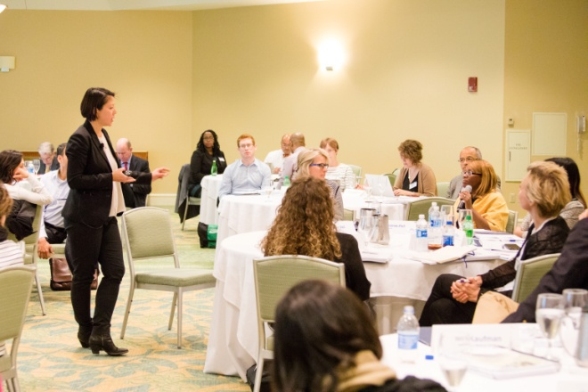
Kick-off Meeting
The two-day DLP kick-off meeting provides you with a framework for understanding how to achieve equity and the solutions you will develop over the course of the year. Experts at the DSC, MGH, and other top health care organizations lead discussions on strategies to achieve equity and inclusion and how to foster the leadership skills to implement these strategies. Examples of the topics covered during the kick-off meeting include:
- Using the Kotter Model to Lead Change
- Understanding Our History and the Long-Lasting Impact of Segregation in Health Care
- Developing a Diverse Pipeline and Organization
- Collecting Race and Other Social Determinants of Health
- Developing Quality Dashboards and Interventions to Achieve Equity and Inclusion
- Understanding Your Organization’s Culture and Identifying Strategies for Improvement
- Partnering with the Community in Research and as an Anchor Institution
Due to COVID-19 related restrictions, the kick-off meeting for the 2021-22 DLP cohort will be held virtually via Zoom. We had great success hosting an interactive and engaging virtual meeting during last year’s kick-off and look forward to taking advantage of this platform to connect despite the challenges posed by COVID-19.

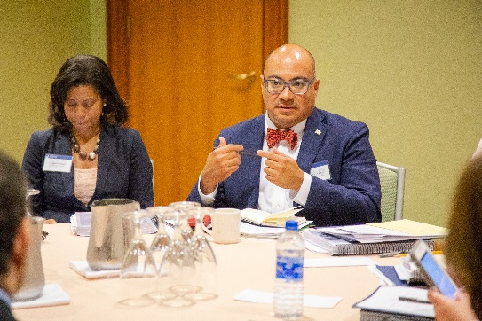
Strategic Planning & Technical Assistance
The goal of the DLP is to provide you with tools that can be immediately deployed within your organization. That’s why we ask every participant to enter the DLP program with the intention to either develop a year-long strategic plan that will be used as a blueprint for improving equity, or to advance a component of a specific project to address disparities. A project can be continuing an initiative already in progress or taking the first step on a new initiative. Examples include:
- Implementing a system to collect patients’ race and other social determinants of health data;
- Creating an “equity dashboard” to report quality data stratified by race and other social determinants of health;
- Developing a training program to address unconscious bias;
- Evaluating a disparity/equity quality improvement intervention; or
- Partnering with community to become an anchor institution.

Whether tackling a strategic plan or a project, as an applicant you must propose the ways in which you would advance this work over the course of the year through participation in the DLP.

Throughout the year, the DSC will then work with you to achieve your project goals through technical assistance, including three interactive web-based calls that include the entire class, as well as two calls with a smaller group of DLP participants working on similar projects or in a similar context.
“DLP offered me easy milestones and rest points in completion of my project. Because working on the project wasn't my only project, it gave me an opportunity to really sit with accomplishments and strategize how to elevate the work among our leaders.”
–DLP Alum

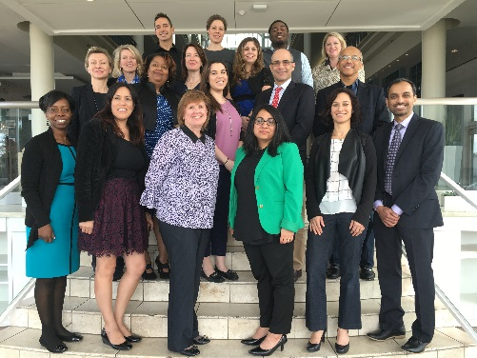
Closing Meeting, Final Project Presentation, and Kick-Off Meeting for the Incoming DLP Cohort
The program ends with a one-day closing meeting for your class, where your team will present your work and lessons learned. Results will be shared with your peers, offering another opportunity to fine-tune your project and identify concrete steps forward, as well as interact and network with your peers.

When the course is over, you will receive continuing education credits and a certificate of completion. All DLP projects will be highlighted on the DSC website, https://mghdisparitiessolutions.org/, and some may be featured in our web seminars, case studies, and press releases. Several projects will be chosen to receive an award for innovation, further elevating the visibility of this work within their organization.

Immediately following the closing meeting, we will host the two-day kick-off meeting for the incoming DLP class. Members of your outgoing class are invited to participate in the kick-off meeting as an opportunity to meet new DLP class participants and listen in on panels relevant to your current disparities work at your organization. You are not required to attend this kick-off meeting, but we have heard from many DLP alumni who have returned to attend kick-off meetings that it’s an opportunity to hear and learn new things given that you may be in a different stage in implementing disparities work.

Can my organization afford the DLP?
Health care organizations that adapt to meet the needs of an increasingly diverse patient population – and ensure that they receive high-quality, value-based care – will ultimately lead in tomorrow’s health care marketplace.

At $9,500 per person, the DLP is a smart investment to ensure your organization is ready for the changes ahead. This fee, due on September 10, 2021, after your acceptance to the program, covers all program activities, including all training sessions and program materials. Please note participants are responsible for booking and covering the cost of hotel and travel to in-person meetings. Due to COVID-19, the 2021 Kick-Off Meeting will be virtual, so participants will not incur travel costs.

Below are some area hotels within 0.5 miles or less of the 2022 Closing Meeting and incoming class Kick-Off Meeting location at the Wyndham Boston Beacon Hill. We recommend booking your stay as early as possible, as hotels in the area fill up quickly.
​
Wyndham Boston Beacon Hill (Meeting venue, 3-star hotel)
The Liberty (0.2 miles from venue, 4-star hotel)
The Whitney Hotel Boston (0.3 miles from venue, 4-star hotel)
The Boxer Boston (0.4 miles from venue, 4-star hotel)
Kimpton Onyx Hotel (0.5 miles from venue, 4-star hotel)
Hotel Indigo Boston Garden (0.5 miles from venue, 3-star hotel)

Scholarships: Partial scholarships may be available for individuals and teams from public hospitals, Medicaid health plans, and community health centers. Other organizations may be considered but are given lower priority. If you require tuition assistance, please include a separate letter of request on your organization’s letterhead with your completed application. Please include the amount of tuition assistance requested for your organization and explain your need for financial assistance.

Will I have time for the demands of the course?

We recognize that our participants are juggling many responsibilities and have therefore streamlined our program to be flexible and easily fit into your schedule.

The time commitment of the program is tailored to be minimal. Dates of the web-based calls with the class will be released prior to the kick-off meeting so you can block the time in your calendar. These meetings are recorded and archived so you can access them at your convenience if you can’t attend. In-person meetings in Boston require some time commitment due to traveling. This time commitment will be reduced in 2021, as the kick-off meeting will be virtual.

We also encourage DLP participants to choose an existing project or something they are currently tasked with so that it integrates well with your current responsibilities (rather than an extra add on). And since you will be working on a live plan or project for your organization, you’ll be learning even as you accomplish goals you’re tasked with meeting. Lastly, we recommend a team of 2 or more to distribute the time commitment among team members.

Many folks have initial reservations about the time commitment, but our team works hard to tailor it to your needs, build flexibility into the program, and make it realistic given how busy everyone is.

With health care reform creating a strategic imperative for organizations to reduce disparities and pave the way for quality care for every patient, your investment of time and money into the DLP will create immediate return.
“In health care reform, the ‘meaningful use requirement’ includes collecting patient demographic data, for example on language and race. We met the requirement this summer because of the project I started at DLP. If we didn’t meet it, we would have lost millions of ‘meaningful use’ dollars.”
–Public and Private Hospital Executive

How Do I Apply?

Application Requirements
To maintain an effective learner-to-faculty ratio, and so that every participant can benefit fully, we limit the number of participants who participate in the DLP each year. We will review your application based on the following criteria:

- Level of organizational commitment to the applicant’s efforts as measured by:
- Letter of support signed by a member of your senior leadership or board, authorizing the time you will commit to the DLP and support for your tuition and travel expenses (templates will be provided); and
- Resources available (time and financial) within your organization to start or advance the project you take on through the DLP.
- Your commitment and ability to improve quality, achieve equity, and address racial and ethnic disparities at your organization, as described in your short essay.
- Your role and capacity to lead your organization toward change.
Application Timeline
We encourage you to submit an Intent to Apply form prior to submitting a complete application. Both are available on our website at www.mghdisparitiessolutions.org.

The DLP 2021-2022 Virtual Kick-Off Meeting will take place Oct. 7-8, 2021. Please review the application timeline and schedule below:

June 25, 2021 | Intent to Apply (recommended but not required)
July 9, 2021 | DLP Full Application due
August 6, 2021 | DLP applicants notified
August 20, 2021 | Acceptance deadline
September 10, 2021 | Tuition payment due
October 7-8, 2021 | Virtual Kick-Off meeting
Date TBD – Sept/Oct 2022  (1 day) | Final Project Presentation at DLP Closing Meeting, Wyndham Boston Beacon Hill, Boston, MA
Dates TBD – Sept/Oct 2022  (2 days following Closing Meeting) | Optional attendance at the 2-day incoming DLP class Kick-Off Meeting, Wyndham Boston Beacon Hill, Boston, MA

Policies
- Cancellations/Withdrawals: Please submit any withdrawal in writing. Cancellation notices received after August 20, 2021 but before September 10, 2021 will be charged a 25% processing fee. Cancellations made after September 10, 2021 will not receive a tuition refund.
- Continuing Education Credit: This program has been planned and implemented in accordance with the Essential Areas and policies of the Accreditation Council for Continuing Medical Education, through the joint sponsorship of the National Committee for Quality Assurance (NCQA) and Massachusetts General Hospital. This activity has been approved for AMA PRA Category 1 Credit™. NCQA is accredited as a provider of continuing nursing education by the American Nurses Credentialing Center’s Commission on Accreditation; continuing nursing education contact hours will be provided to participants.

To successfully complete this activity and receive CME or CNE credit, you must: sign the participant roster (at in-person meetings), remain for the entire program, and complete and submit a program evaluation. A certificate of completion specifying applicable credits will be available for each participant after the program.

Accessibility
The Disparities Solutions Center at Massachusetts General Hospital (MGH) considers all applicants and program participants without regard to race, color, national origin, age, religious creed, sex, gender identity, sexual orientation, or ability. We encourage participation by all individuals. If you need any of the auxiliary aids or services identified in the Americans with Disabilities Act, please describe your needs in writing and include it with this application.

Who leads the DLP?

Aswita Tan-McGrory, MBA, MSPH, is the Director at the Disparities Solutions Center and Administrative Director of the Mongan Institute. In her role as Director at the Disparities Solutions Center, Ms. Tan-McGrory leads the Center’s portfolio of projects focused on addressing racial and ethnic disparities in health care. Ms. Tan-McGrory also travels across the country to speak to organizations about how race, ethnicity, and language impact the quality of care. Ms. Tan-McGrory serves on several executive committees, including the MGH Diversity Committee, and the Partners Health Equity and Quality Committee. In addition, Ms. Tan-McGrory sits on the board of the Massachusetts Public Health Association and is Adjunct Faculty at Northeastern University. Ms. Tan-McGrory currently serves on the MA Executive Office of Health and Human Services’ Quality Measurement Alignment Taskforce.

As Administrative Director of the Mongan Institute, Aswita works in tandem with the Director to provide overall strategic and operational responsibility for Mongan Institute staff, programs, expansion, and execution of its mission. In addition, she works with the Mongan Institute Unit leadership to facilitate interdisciplinary team work, manage and improve operations, provide data and decision-support, manage team initiatives and projects and provide oversight for strategic initiatives as the Institute moves forward under the direction of the Mongan Institute Director. The Mongan Institute in the Department of Medicine at Massachusetts General Hospital is dedicated to supporting research across MGH in the areas of population and health care delivery science. The Mongan Institute brings together nine existing research centers: the Medical Practice Evaluation Center, the Health Policy Research Center, the Global Health Research Center, the Disparities Solutions Center, the Disparities Research Unit, the Cancer Outcomes Research Program, the Clinical and Translational Epidemiology Unit, the MGH Health Decision Science Center, and the Tobacco Research and Treatment Center, as well as a developing program in primary care research in the Division of Internal Medicine.

Ms. Tan-McGrory’s interests are in providing equitable care to underserved populations and she has over 20 years of professional experience in the areas of disparities, maternal/child health, elder homelessness, and HIV testing and counseling. She received her Master of Business Administration from Babson College and her Master of Science in Public Health, with a concentration in tropical medicine and parasitology, from Tulane University School of Public Health and Tropical Medicine. Ms. Tan-McGrory is a Returned Peace Corps Volunteer where she spent 2 years in rural Nigeria, West Africa, on water sanitation and Guinea Worm Eradication projects.

She received a YMCA Achievers award in 2017 for community service and professional achievement, and in 2016 was selected as a Pioneer as part of a groundbreaking initiative Children’s Wellbeing initiative by Ashoka Changemakers and the Robert Wood Johnson Foundation.

Dr. Joseph Betancourt, MD, MPH, is the MGH/MGPO Senior Vice President for Equity and Community Health, the founder, senior advisor and faculty of the Disparities Solutions Center (DSC) at MGH, Faculty at the Mongan Institute, an Associate Professor of Medicine at Harvard Medical School and a practicing Internal Medicine physician. He has also served on the leadership team of the MGH Center for Diversity and Inclusion. Dr. Betancourt is a nationally and internationally recognized expert in health policy, health care disparities, diversity, and cross-cultural medicine, and has served on several Institute of Medicine Committees, including those that produced the landmark reports, Unequal Treatment and Increasing Diversity in the Healthcare Workforce. Dr. Betancourt has secured grants and contracts that have led to over 60 peer-reviewed publications, and advises private industry, government, and not-for-profit health systems on approaches to eliminating racial and ethnic disparities in health care. He sits at on the Board of Trinity Health, a large national health system; and sat on the Boston Board of Health and the Board of Neighborhood Health Plan in Boston. He is a 2015 Aspen Institute Health Innovator Fellow.

Dr. Betancourt received his Bachelor of Science from the University of Maryland, his medical degree from Rutgers-New Jersey Medical School, and completed his residency in Internal Medicine at the New York Hospital-Cornell Medical Center. Following residency, he completed The Commonwealth Fund-Harvard University Fellowship in Minority Health Policy and received his Master’s in Public Health from the Harvard School of Public Health.

Lenny López, MD, MDiv, MPH, is Senior Faculty at the Disparities Solutions Center, Chief of Hospital Medicine and Associate Professor of Medicine at the University of California San Francisco. Dr. López is an internist trained at the Brigham and Women’s Hospital (BWH), who completed the Commonwealth Fund Fellowship in Minority Health Policy at the Harvard School of Public Health and a Hospital Medicine fellowship at BWH. Dr. López joined the Mongan Institute for Health Policy (MIHP) in 2008 after his research fellowship in General Internal Medicine at Massachusetts General Hospital (MGH) and was an Assistant Professor of Medicine at Harvard Medical School until 2015. With an ultimate goal of reducing healthcare disparities in cardiovascular disease and diabetes, his current research addresses issues relating to patient safety and language barriers, optimizing primary care clinical services for Latinos with cultural and linguistic barriers, and using health information technology to decrease disparities. A second line of research is investigating the epidemiology of acculturation among Latinos in the US and its impact on the prevalence and development of cardiovascular disease and Type II diabetes. This research will help inform how to better design clinical interventions for improving chronic disease management among Latinos. Finally, Dr. López also teaches medical students and residents, with lectures and preceptorships. Dr. López received his medical degree from University of Pennsylvania in 2001, and completed his residency at Harvard Medical School, Brigham and Women’s Hospital, Boston, in 2004. At Harvard University, he received a Master of Divinity in 1999 and a Master of Public Health in 2005.

Alden M. Landry, MD, MPH is an Assistant Professor of Emergency Medicine physician at Beth Israel Deaconess Medical Center, Assistant Dean for the Office for Diversity Inclusion and Community Partnership, Associate Director and Advisor for William B. Castle Society, and Director of Health Equity Education at Harvard Medical School. He also serves as Senior Faculty at the Disparities Solutions Center at Massachusetts General Hospital and is the founder and co-director of the non-profit organization Motivating Pathways. He strives to lead efforts for the Department of Emergency Medicine, the hospital and the medical school that will address health disparities and improve quality of care for the most disenfranchised.

In addition to his clinical interests, Dr. Landry is involved in research on Emergency Department utilization trends, disparities in care and quality of care. He also co-instructs a course at the Harvard T.H. Chan School of Public Health and teaches cultural competency to residents and physicians. Dr. Landry promotes careers in the health professions to under-represented minorities and mentors scores of pre-medical students, medical students, residents, fellows, and junior faculty. Dr. Landry also leads the Tour for Diversity in Medicine, (www.tour4diversity.org) an effort to increase the number of underrepresented minorities in medicine, dentistry, and other biomedical careers.

Dr. Landry has been recognized by his peers and colleagues as a leader in health equity and social justice. He has received numerous awards for his public health work and efforts to promote health care workforce diversity. He was recently awarded the Outstanding Academician Award by the Academy for Diversity and Inclusion in Emergency Medicine of the Society of Academic Emergency Medicine and the Albert Frechette Award from the Massachusetts Public Health Association.

Dr. Landry received his Bachelor of Science degree from Prairie View A&M University in 2002 and his medical degree from the University of Alabama Birmingham School of Medicine in 2006. He completed his residency in Emergency Medicine at the Beth Israel Deaconess Medical Center in 2009. In 2010, he earned a Master’s in Public Health degree from the Harvard T.H. Chan School of Public Health and completed the Commonwealth Fund Fellowship in Minority Health Policy at Harvard University. He received the Disparities Solutions Center/Aetna Fellow in Health Disparities award in 2010-2011. ​

Karey S. Kenst, MPH, is the Senior Program Manager at the Disparities Solutions Center. They joined the DSC in 2012 with professional experience in the areas of international humanitarian response, LGBTQ+ health, and sexual violence prevention and response. At the DSC, they manage a range of programs and projects, including: the Disparities Leadership Program; production of MGH’s Annual Report on Equity in Healthcare Quality; quality improvement initiatives with the Department of Obstetrics and Gynecology; research on sexual orientation and gender identity data collection in clinical settings; development and implementation of an educational program on caring for patients with limited English proficiency; and implementation of the CMS Office of Minority Health’s equity plan. Karey manages implementation of the Disparities Leadership Program, a year-long executive leadership program designed to help leaders advance strategies and initiatives to advance equity in their own organizations. They also contribute to educational initiatives to improve quality and equity of care for racially and ethnically diverse populations and sexual and gender minorities, including producing the Dismantling Disparities podcast. Karey brings a social and racial justice lens to working with institutions and communities and believes in collaborative, interdisciplinary approaches that reach beyond clinical settings to address the social determinants of health. They earned a Master of Public Health with a concentration in Social and Behavioral Sciences from the Boston University School of Public Health and a Bachelor of Arts in sociology from the University of Wisconsin.
“The DLP is a great network with members who are knowledgeable and in the leading edge of this line of work. It enables me to show myself as a better qualified professional. I am able to say that I was a participant in a program with an excellent reputation whose members are national leaders, experts, and practitioners.”
– DLP Alum

Where can I find more information?

For more information on the DLP and the Disparities Solutions Center at MGH, please visit:
https://www.mghdisparitiessolutions.org/disparities-leadership-program

To see a list of DLP alumni, please visit:
https://www.mghdisparitiessolutions.org/alumni-network

To read the peer reviewed article in Health Affairs on lessons learned from the DLP, as well as the external assessment of the DLP and its impact, visit:
https://www.mghdisparitiessolutions.org/dlp-evaluation

For additional information, contact:
Karey Kenst, MPH
Senior Program Manager, The Disparities Solutions Center
Massachusetts General Hospital
100 Cambridge Street, Suite 1600
Boston, MA 02114
Email: kkenst@partners.org
Phone: (617) 724-7658

